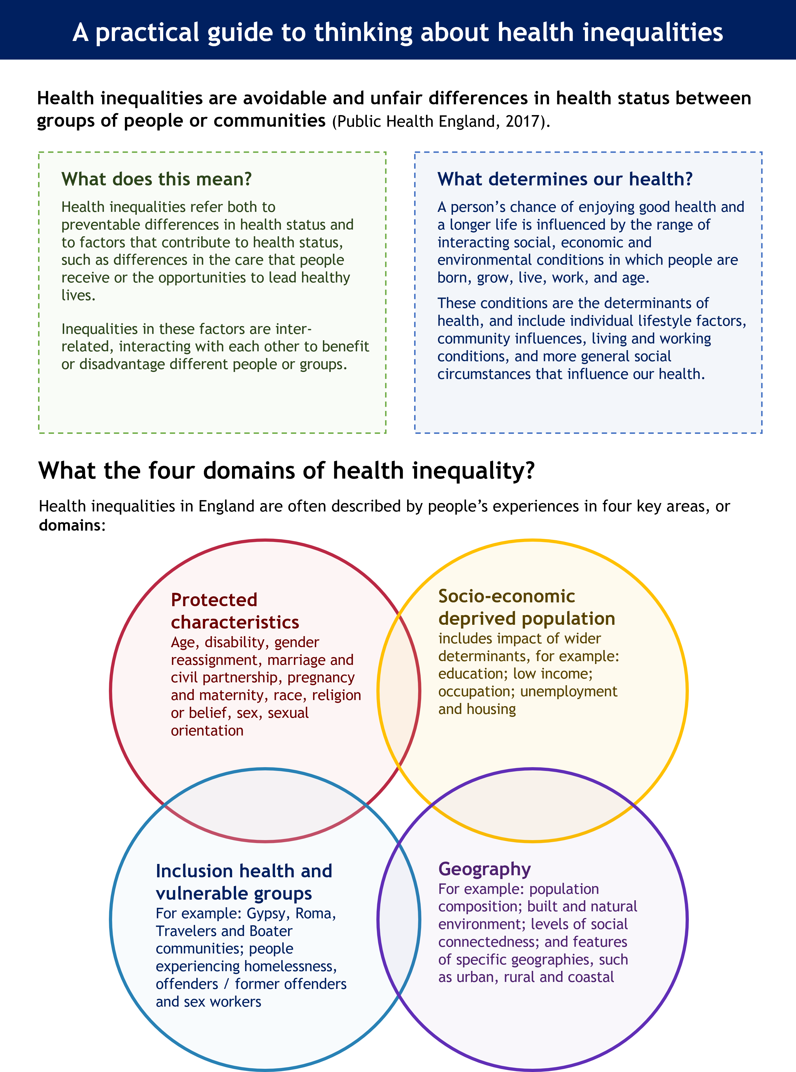Source: OHID 2021, adapted from [Place Based Approaches to Reduce Inequality](https://www.gov.uk/government/publications/health-inequalities-place-based-approaches-to-reduce-inequalities/place-based-approaches-for-reducing-health-inequalities-main-report)

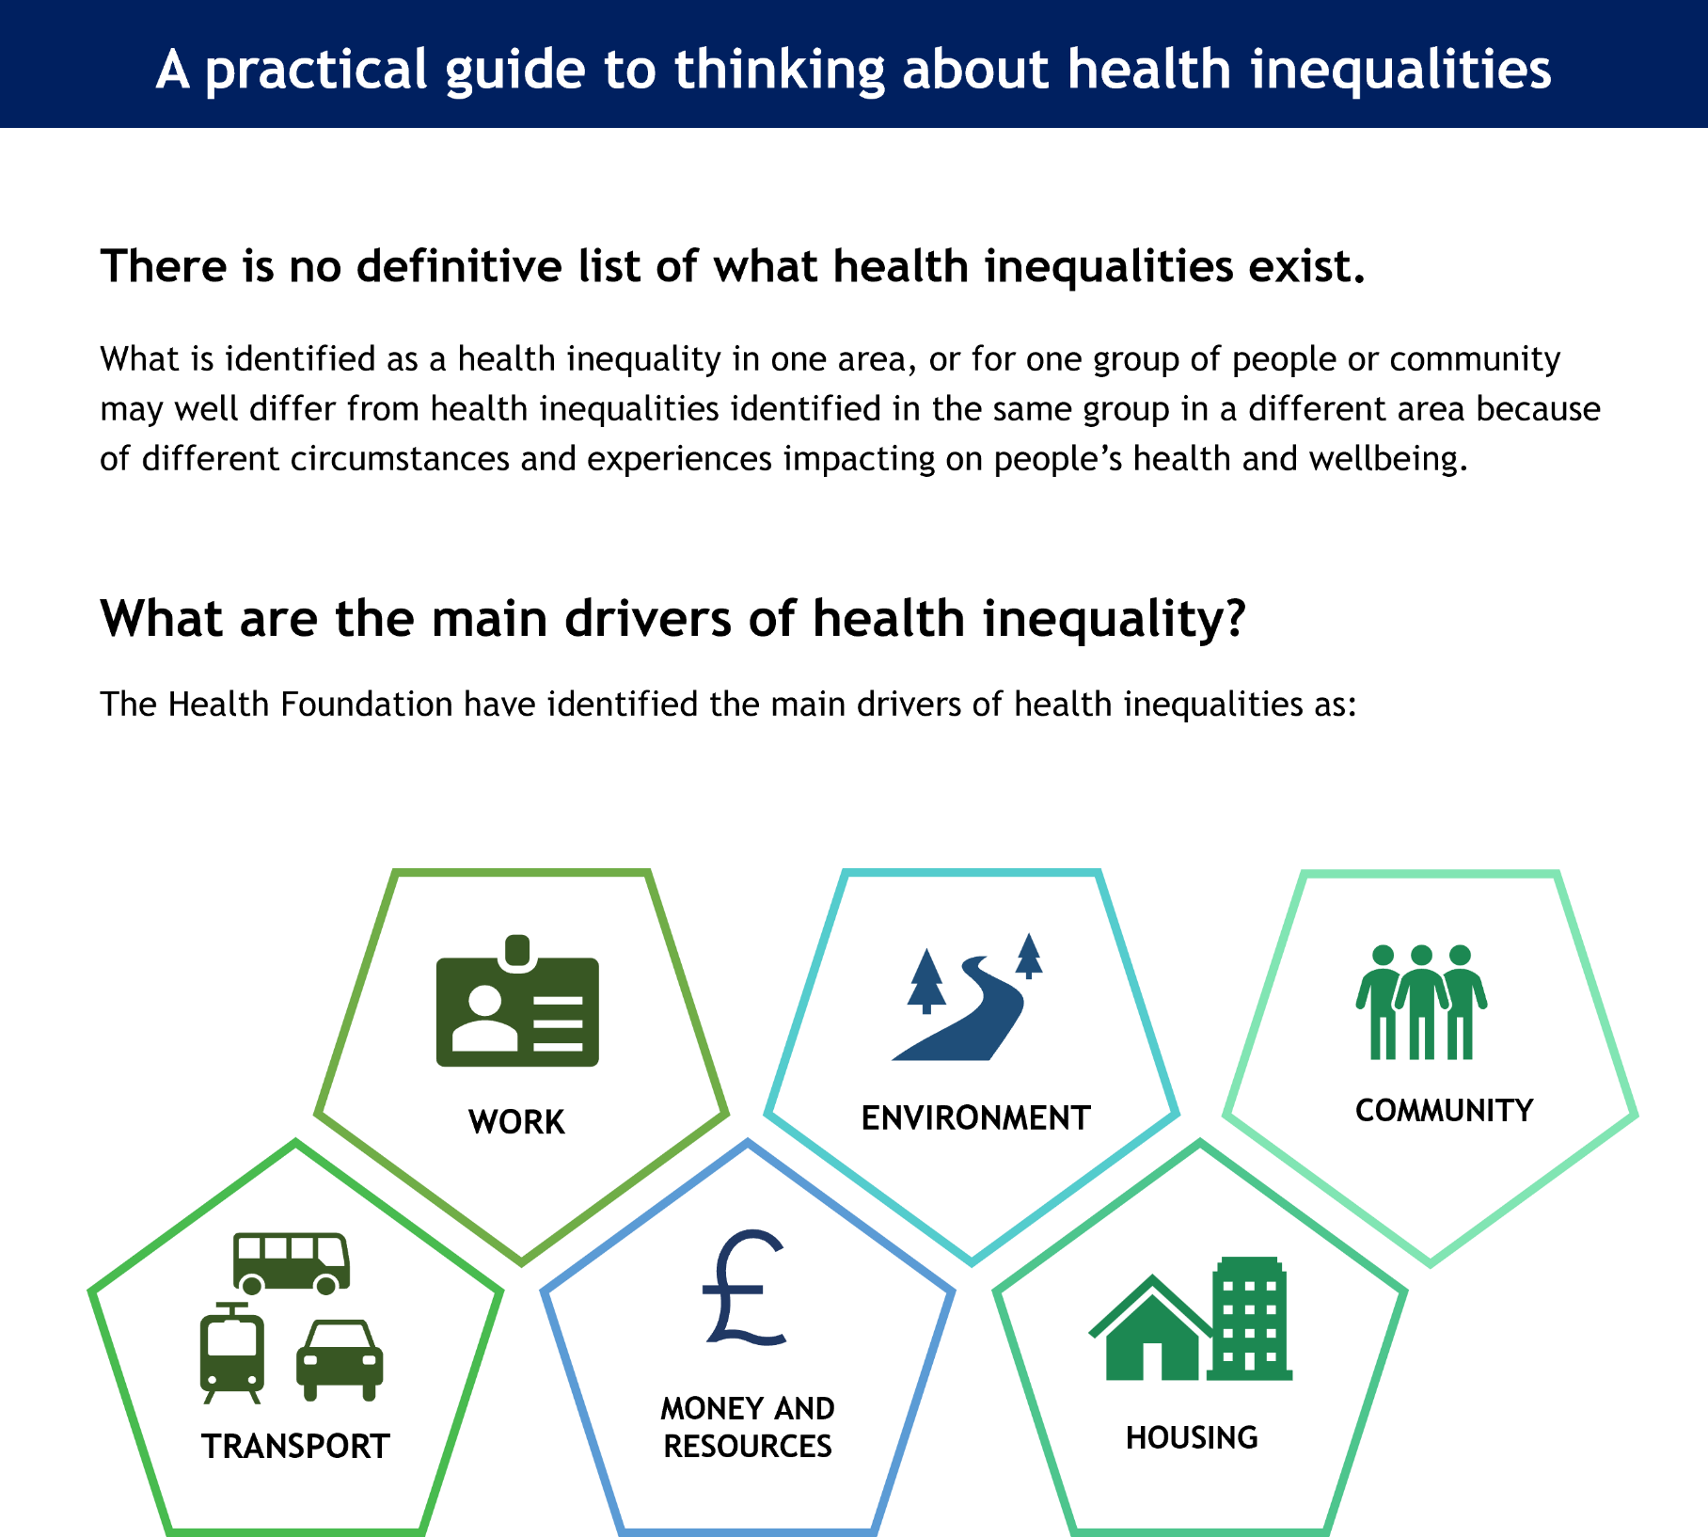

Source: adapted from [Health Foundation](https://www.health.org.uk/evidence-hub), 2023

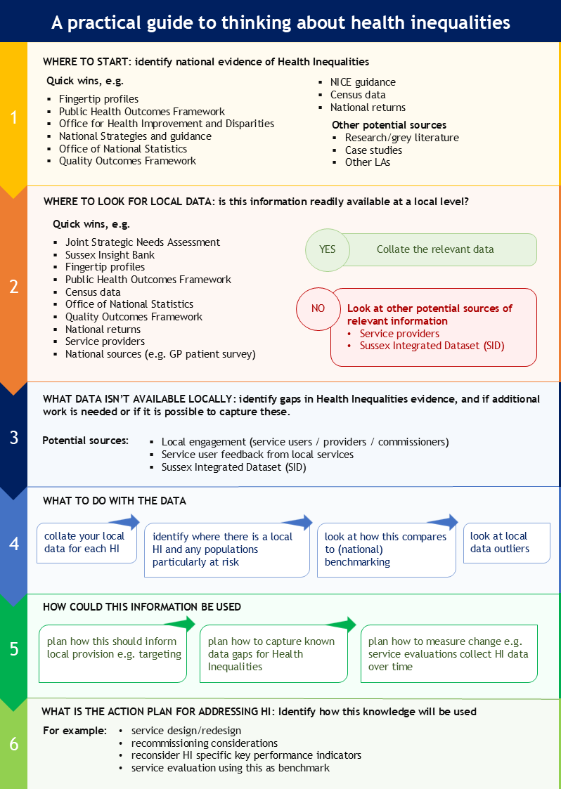

|  |  |
| --- | --- |
| **A practical guide to thinking about health inequalities** | |
| **Where is there national evidence of Health Inequalities about my area of interest?** | |
| Type your answer here | |
| Collect the evidence​ | |
| **Where is there readily available local information on health inequalities in my area of interest?** | |
| I can collate data from the following sources: | |
| There is no readily available information so I could look at the following sources: | |
| Collect the evidence | |
| **What gaps in health inequalities data have I identified locally, can I capture this information?** | |
| Additional research or engagement work to consider​: | |
| New data analysis using local data that is collected but not routinely looked at​: | |
| Collect the evidence if possible​ | |
| **What does this information show us about health inequalities?** | |
| What health inequalities have I identified |  |
| How do these compare to (national) benchmarking |  |
| Are there any health inequalities which appear worse or better than would be expected? |  |
| Which populations appear to be particularly at risk of health inequalities |  |
| **How will this information be used?** | |
| Add your answer | |